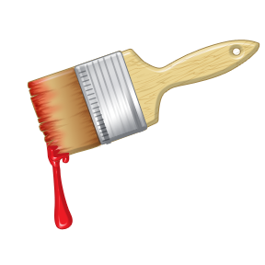
D.CROMBIE
Painter & Decorator
Tel; 07986 211849
dscrombie@sky.com

12th February 2020

Quote for decoration of timber areas of balconies at Saxon Court, Guys Cliffe Avenue, Leamington Spa.

Prepare all timber areas, apply two coats of anti-slip woodstain.

Materials £270.00
Labour £600.00

12 decks; 6 @ 2m squared, 4 @ 3m squared & 2 @ 1m squared.
Measurements are approximate.

